Chapter 6 Sustainability
extra worksheet 1: Available nitrogen

The nitrogen cycle
Nitrogen (N) is an essential component of the molecules that carry genetic information, and of proteins, the building blocks of life. All organisms require nitrogen to live and grow. Seventy-eight per cent of air is nitrogen in the form of N₂ molecules. The two atoms of nitrogen are held together strongly making the molecule relatively chemically inactive and therefore unavailable to living things. For plants and animals to be able to use nitrogen, it must be in a chemically available form such as ammonium (NH₄⁺) or nitrate ions (NO₃–), or the compound urea (NH₃)₂CO. Nitrogen is often in short supply in natural ecosystems and is a limiting factor for plant growth.
There are five main processes in the nitrogen cycle (see Figure 1):
• nitrogen fixing
• nitrification
• nitrogen uptake by plants
• decomposition
• denitrification.
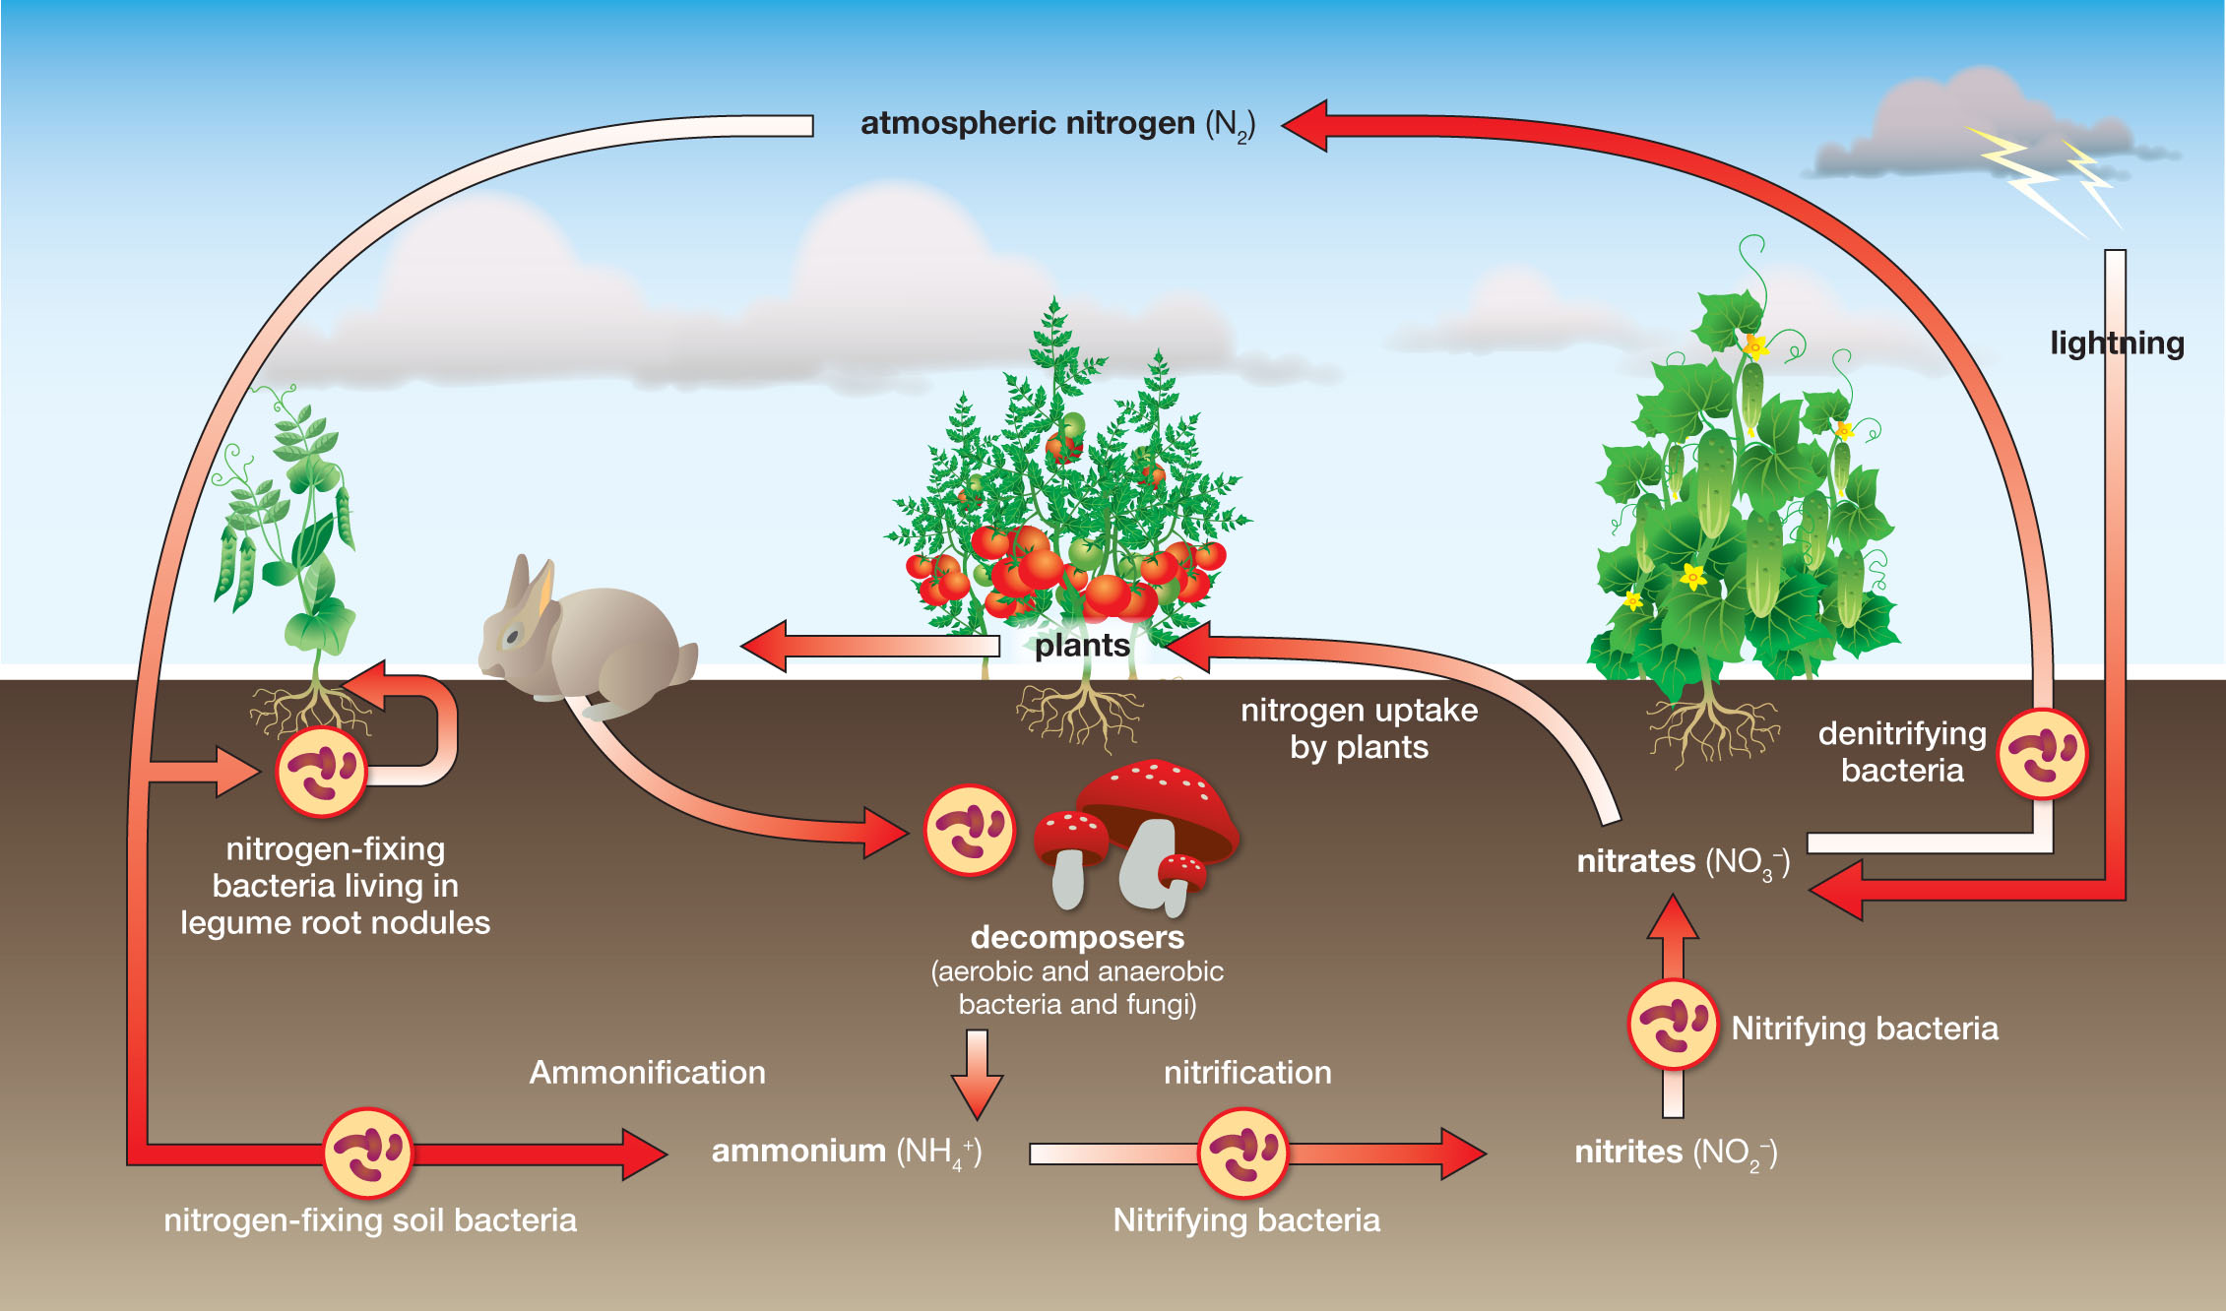
Figure 1 The nitrogen cycle.

Nitrogen fixation
Some bacteria, for example those of the genus Rhizobium, can fix nitrogen (convert nitrogen into a usable form) through metabolic processes. Many nitrogen-fixing bacteria live in a symbiotic (depending on each other for survival) relationship with host plants, especially leguminous plants. Other nitrogen fixing bacteria are free-living in soils and in water.
Small, but significant amounts of nitrogen are fixed from the air by high-energy natural events such as lightning, forest fires, and even hot lava flows. The high energy involved in these natural occurrences breaks the bonds between the nitrogen atoms in the N₂ molecule, making individual atoms available for nitrogen-fixing chemical reactions.

Human alteration of the nitrogen cycle
Early in the 20th century Fritz Haber, a German scientist, developed a way of fixing nitrogen in a chemical reaction at high temperatures and pressures. He created nitrogen-rich chemical fertilisers that could be applied directly to the soil. By using nitrogen-rich fertilisers, the yield of crops has improved and productivity of agricultural land has increased. The protein content of the crops and the food value of the crops have also increased. This has helped feed the rapidly increasing human population.
Burning fossil fuels, using chemical nitrogen-rich fertilisers and cultivation (growing) of legumes all add fixed nitrogen to the biosphere. Within the last century, through these activities, humans are greatly increasing the amount of nitrogen cycling between the living world and the soil, water and atmosphere. We have more than doubled the rate of nitrogen entering the land-based nitrogen cycle.

Questions
1 Explain why nitrogen in the air is not available to plants and animals.

2 Describe how lightning increases the amount of nitrogen available for plant growth.

3 Explain the process that Fritz Haber developed, what he created and how this helped increase food production.

4 List ways that humans have increased the amount of nitrogen available for cycling.

5 Use information from Figure 1 to summarise what occurs in each of the five main processes of the nitrogen cycle.

6 Temperature, moisture and pH all affect the activity of bacteria. Deduce why these factors would also affect the rate of nitrogen cycling.

7 What if something happened that caused the soil in an area to be sterilised (all bacteria are killed)?
a State the processes of the nitrogen cycle that could still take place.

b Propose how long the processes would be able to continue.

c Justify your response.

8 Peas and beans are leguminous plants.
a Explain why planting more of these food crops would affect the nitrogen cycle.

b Describe the immediate effect of this change.

